

American International University-Bangladesh (AIUB)

**Department of Computer Science**

**Faculty of Science & Technology (FST)**

**Research Methodology**

**Assignment**

Submitted By

|  |  |  |  |  |  |
| --- | --- | --- | --- | --- | --- |
| **Semester: Summer_2023-2024 FINAL TERM** | | | | **Section:** | **Group No:** |
| SL | SN | Student Name | Student ID | Individual  Contribution (100%) | Total Marks: 40 |
| Earned Marks: |
| **A** | 09 | Md. Shohanur Rahman Shohan | 22-46013-1 | 32% |  |
| **B** | 29 | Farjana Yesmin Opi | 22-47018-1 | 30% |  |
| **C** | 30 | Md. Abu Towsif | 22-47019-1 | 38% |  |
| **D** |  |  |  |  |  |

Submission Date: 19th February, 2024

**The assignment will be Evaluated for the following Course Outcomes**

|  |  |
| --- | --- |
| CO1: *Evaluate* all relevant resources for designing a computer science and engineering solution and determine the level of novelty of the research. | Total Marks (9) |
|  |
| **Problem Analysis and use of State-of-the-Art** **Resources:** Discuss the research problem background with best use of state‐of‐art literature, resources, and technologies to produce a significant result that is likely to have a major impact. | [3 Marks] **A: B: C: D:** |
| **Critical Reflection and Creativity in Research Objective:** Deep insight demonstrated and presented a creative solution to the real‐life problem. And Results are critically confronted with various existing literature | [3 Marks] **A: B: C: D:** |
| **Novelty and Contribution of the Research:** Elaborately discuss and identify the contribution of the research to the development of scientific concepts by recognizing the research gaps of existing research and developments. | [3 Marks] **A: B: C: D:** |

|  |  |
| --- | --- |
| CO2: *Analyze* the collected data to provide valid solution of the research problem acknowledging the limitations. | Total Marks (9) |
|  |
| **Data Analysis:** Elaborately discuss the research method, its appropriateness and details on data collection, analysis, and synthesis for proposing valid solution to the research problem. | [3 Marks]  **A: B: C: D:** |
| **Solution and Validation:** Elaborately discuss the solution of the research problem by establish a direct connection between proposed solutions with the research objective based on the collected research data. | [3 Marks]  **A: B: C: D:** |
| **Limitation and Scope of Future Studies:** Elaborately discuss abstract and concluding remarks of the research with its limitations and scope of future studies. | [3 Marks]  **A: B:  C: D:** |

|  |  |
| --- | --- |
| CO3: Determine and Demonstrate professional codes of ethics and standard in conducting research considering public safety; the impacts of engineering activity; economic, social, cultural, environmental and sustainability. | Total Marks (9) |
|  |
| **Free of Plagiarism, Data Falsification Citations and References:** Submit plagiarism free research paper (similarity index is <10%). In-text citations and reference list citations were complete and properly formatted in APA or any other standard style. The Research data is not fabricated or altered intentionally to fit into the predetermined research findings. Materials are properly cited and referenced if they are taken from other sources. And not attributed to a source from which it has not been obtained *(i.e., false citation)* | [3 Marks]  **A: B: C: D:** |
| **Professional codes of ethics and standard:** The research elaborately demonstrates professional codes of ethics and standard in conducting research considering public safety; the impacts of engineering activity; economic, social, cultural, environmental and sustainability. | [3 Marks]  **A: B: C: D:** |
| **Formatting and Submission:** Submitted in due time, the report is complete and there are no errors in spelling, format, and grammar. Consistently  presents a logical and effective organization. | [3 Marks]  **A: B: C: D:** |

|  |  |
| --- | --- |
| CO4: *Defend* the research solutions based on complex engineering activities by delivering an effective presentation to the audience. | Total Marks (9) |
|  |
| **Presentation delivery (eye contact and body language):** Keeps eye contact with audience all the time, use natural gestures and movements, looks confident. | [3 Marks]  **A: B: C: D:** |
| **Enthusiasm/Audience Awareness:** Demonstrate strong enthusiasm about the topic, significantly increases audience understanding and knowledge of the topic, convinces an audience to recognize the validity and importance of the subject. | [3 Marks]  **A: B: C: D:** |
| **Creativity and Use of Media:** The presentation was creative in design and effectively use multimedia. | [3 Marks]  **A: B: C: D:** |

|  |  |
| --- | --- |
| Viva/Defense | Total Marks (4) |
| Defend the research in performance in the question/answer session. | **A: B: C: D:** |

Designing an Intelligent Accommodation System for Rohingya Refugees: Integrating AI, Sustainability, and Economic Empowerment

MD. Abu Towsif, Farjana Yesmin Opi, Md. Shohanur Rahman Shohan  
Department of Computer Science  
American International University – Bangladesh  
(22-47019-1, 22-47018-1, 22-46013-1)@student.aiub.edu

**Abstract**

This paper presents a framework for an intelligent accommodation system designed to improve living conditions, security, and economic opportunities for Rohingya refugees. Using a systematic literature review (SLR), the study identifies key challenges and proposes an AI-driven model incorporating sustainable infrastructure and community-focused strategies. The framework aims to enhance resource management, security, and productivity within refugee camps, providing a comprehensive approach to addressing both immediate and long-term needs. Findings underscore the potential for integrating technology and local knowledge to foster self-sufficiency and stability. This research offers valuable insights for policymakers and humanitarian organizations, guiding innovative solutions for refugee support and integration.

**Keywords:** Sustainable Refugee Housing, AI-Driven Solutions, Rohingya Refugee Accommodation, Refugee Productivity, Economic Empowerment

INTRODUCTION

**Problem Background**

The Rohingya, an ethnic minority from Myanmar, have faced decades of systemic persecution, leading to mass displacement. With nearly 1,000,000 Rohingya refugees (United Nations High Commissioner for Refugees, n.d.) currently residing in makeshift camps in Bangladesh, there is an urgent need for innovative solutions that not only provide basic accommodation but also promote productivity and self-sufficiency (Milton et al., 2017). The influx of refugees into Bangladesh, particularly in the Cox’s Bazar region, has placed immense pressure on resources and infrastructure. Traditional refugee camps often focus solely on providing immediate relief, such as food and shelter, without addressing long-term sustainability and the potential for refugees to contribute economically and socially (Bhatia et al., 2018).

To illustrate the gravity of the situation, consider the story of Tasmin, a 51-year-old Rohingya woman who fled Myanmar’s Rakhine State after horrific violence was waged against her ethnic minority group in late 2017. Tasmin and her five children escaped to the forests behind their home, hiking for eleven days before reaching the Naf River, which marks the border between Myanmar and Bangladesh. Tasmin’s family was resettled in Kutupalong, where they joined nearly one million other Rohingya refugees. Tasmin's story reflects the extreme trauma and severe hardships that all Rohingya refugees endure in these overcrowded camps, where they face dire living conditions, including inadequate shelter, food shortages, and a lack of basic sanitation and healthcare (Relief International, 2019).

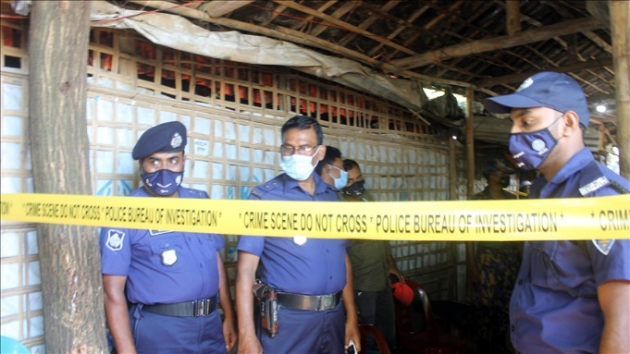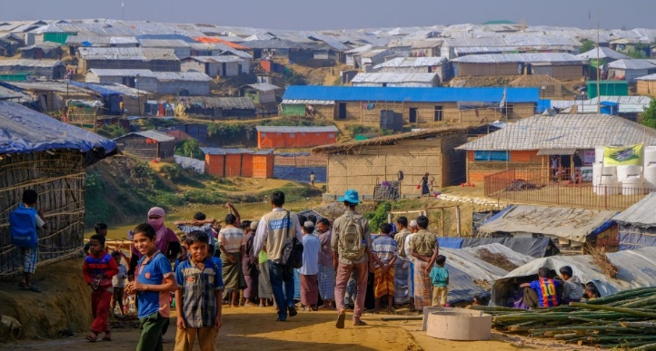

Figure 2 - Police guard madrassa after Rohingya attack in Cox’s Bazar, Oct. 26, 2021. (Benar News, 2021)

Figure 1 - Kutupalong Refugee Camp (Humanity & Inclusion Canada, n.d.)

Adding to these challenges, an alarming rise in crimes, including murders and drug offenses, has been reported in the camps, linked to armed groups like ARSA and RSO (The Daily Star, 2023). The situation is worsened by Rohingya refugees obtaining fake Bangladeshi IDs, creating instability and fear (Dhaka Tribune, 2023). Contributing factors include lack of economic opportunities and a sense of hopelessness, with jobless youths turning to crime for survival and armed groups competing in illegal activities, further escalating violence (Dhaka Tribune, 2023).

The problems that this research aims to address can be broadly summarized into two main issues:

* **Inadequate living conditions and lack of long-term sustainability**: Current refugee accommodations hinder the economic self-sufficiency and social productivity of Rohingya refugees.
* **Escalating security problems within camps**: Issues such as crime and the misuse of identification documents further destabilize the already precarious environment.

This paper addresses the critical need to rethink refugee accommodation from a perspective that includes productivity, self-reliance, and enhanced security.

**Related Studies**

Various studies have examined conditions in Rohingya refugee camps. Bhatia et al. (2018) highlight inadequate facilities and economic opportunities but offer no long-term solutions. Milton et al. (2017) focus on health challenges from overcrowding and poor sanitation but overlook socio-economic factors and technology's role. Karin et al. (2020) emphasizes the critical dearth of food, inadequate housing facilities, and poor access to health services in Rohingya refugee camps but do not explore the potential role of technological advancements in addressing these issues. Hossain et al. (2020) address rising crime and armed groups but do not explore how AI could enhance security.

Despite the valuable contributions of these studies, there is a noticeable gap in the literature regarding integrated solutions that combine sustainable living conditions with productivity-enhancing features and advanced technologies like AI. None of the existing research comprehensively addresses the need for a holistic accommodation system that not only meets the basic needs of refugees but also empowers them to achieve economic self-sufficiency and social productivity while ensuring their security.

This research aims to fill that gap by proposing an intelligent accommodation system that incorporates AI to optimize resource allocation, enhance security, and support economic integration within the refugee camps. By addressing these gaps, this study will contribute significantly to the field of humanitarian aid and refugee studies, offering a model that can be adapted and implemented in similar contexts globally.

**Research Objectives**

This research proposes an intelligent accommodation system for Rohingya refugees that integrates sustainable living conditions, productivity opportunities, and enhanced security. The goal is to create a framework addressing both immediate needs (shelter, sanitation, healthcare) and long-term sustainability (environmental practices, resource availability). Economic activities will be incorporated, promoting refugee self-reliance and transforming camps into productive communities. To address security issues like crime and armed group influence, the framework will leverage AI to enhance security measures and optimize resource allocation. Though the study does not aim to implement the system, it will offer a conceptual model answering: " **How to develop an intelligent accommodation system for Rohingya refugees that facilitates productivity, ensures security, and leverages AI?**"

**Research Contributions**

This study contributes to humanitarian aid, refugee studies, and AI-driven social innovation by presenting a framework for intelligent accommodation systems tailored to Rohingya refugees. It provides insights for policymakers and organizations on using AI to create sustainable, secure environments while enhancing refugee productivity. By integrating AI in resource management and security, the research offers solutions that reduce refugee dependency, promote self-sufficiency, and alleviate the socio-economic burden on host countries

methodology

The methodology of this study is based on a systematic literature review (SLR) approach, designed to comprehensively evaluate existing research and literature relevant to the development of intelligent accommodation systems for Rohingya refugees. This approach ensures a thorough and unbiased collection of data that contributes to forming a robust framework for addressing the research problem. The SLR method follows the guidelines set by Kitchenham et al. (2010) and Petersen et al. (2008), which emphasize the importance of systematic data collection and analysis.

#### Search Strategy

The search strategy employed in this study was designed to locate the most relevant academic and scholarly sources across multiple databases. The selected databases include IEEE Xplore, SpringerLink, ScienceDirect, ACM Digital Library, IGI Global, Google Scholar, and Wiley Online Library. These databases offer extensive coverage of technological and humanitarian literature, essential for the interdisciplinary nature of this research.

#### Keywords and Boolean Logic

A combination of carefully selected keywords was utilized to refine and target the search results. Boolean operators were applied to manage and expand the search results effectively. The following keywords and Boolean logic were used:

* "Rohingya refugees" AND "accommodation system" AND "artificial intelligence"
* "refugee productivity" OR "sustainable refugee camps"
* "AI in refugee security" AND "systematic review"

This strategic combination of search terms helped ensure the search was both comprehensive and focused on relevant studies.

#### Forward and Backward Search Techniques

In addition to the primary search using databases, both forward and backward citation search techniques were employed. This included reviewing the references cited in key articles (backward search) as well as identifying more recent publications that cited these articles (forward search). This approach ensured that all relevant literature, including the most recent studies, was considered in the review process. This comprehensive search strategy minimizes the risk of omitting any critical studies or emerging research.

#### Inclusion and Exclusion Criteria

To ensure the relevance and quality of the reviewed literature, specific inclusion and exclusion criteria were applied throughout the selection process.

### *Inclusion Criteria*

* Peer-reviewed journal articles and conference papers.
* Studies focusing on refugee accommodation, AI applications in humanitarian settings, and security.
* Publications in English.
* Articles published between 2000 and 2024.
* Studies that included abstract or title discussions relevant to refugee accommodation systems or AI in humanitarian settings.

#### Exclusion Criteria

* Non-peer-reviewed articles, such as opinion pieces or editorials.
* Studies not explicitly addressing AI or accommodation systems in refugee contexts.
* Articles where only titles were relevant but lacked substance in abstracts or full texts.
* Publications without sufficient detail or methodological rigor.

#### Selection Process

The selection process was designed to systematically screen studies based on their relevance to the research question

#### Initial Screening

An initial search of the academic databases yielded 87 articles after applying the defined keywords. Titles and abstracts of these papers were reviewed to determine their relevance to the research question. This initial screening was based on whether the articles mentioned AI, refugee accommodation, and security systems, among other factors.

#### Secondary Filtering

Following the initial screening, the inclusion and exclusion criteria were applied to refine the list. This stage involved filtering out studies that lacked peer-reviewed rigor or relevance to AI-driven accommodation systems for Rohingya refugees. After this stage, 30 articles remained for further review.

#### Final Selection

A detailed review was conducted on the remaining 30 articles, which led to a final selection of 13 studies. These were chosen based on their direct relevance to the research objectives, as well as their methodological rigor. Both free full-text articles and those available only through abstracts were considered in this review, with abstracts used to extract data when full texts were not accessible.

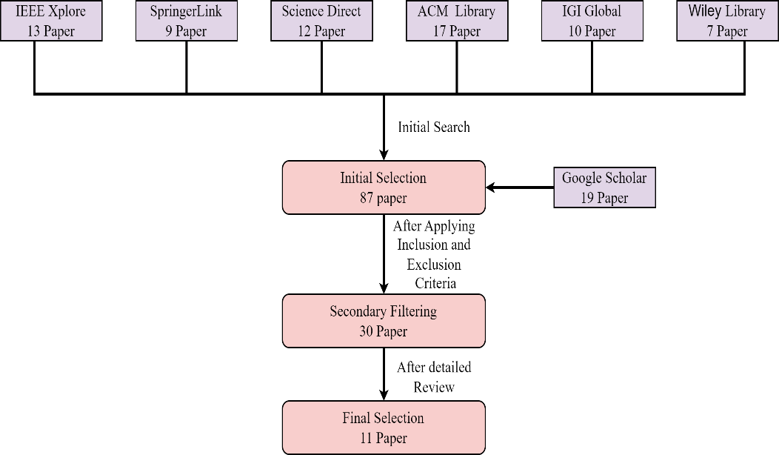

**Figure 3 -** Literature Search and Article Selection for Systematic Review

#### Data Extraction and Synthesis

Data extraction was performed with a standardized approach to ensure consistency. For freely available articles, detailed information was gathered from all sections including the abstract, methodology, results, and discussion. For articles where only abstracts were accessible, data extraction focused on the abstracts. This method facilitated a broad review of available literature while acknowledging the limitations imposed by paywalls.

#### Data Extraction Process

A standardized data extraction form was used to methodically collect information from each study. For fully accessible articles, comprehensive data were extracted across all sections: abstract, introduction, methodology, results, and conclusions. This thorough examination was aimed at obtaining a holistic understanding of each study's contributions. For articles limited to abstracts, the extraction focused on gleaning the most significant points that related to the research objectives of developing an intelligent accommodation system for Rohingya refugees.

#### Quality Assessment

Quality assessment was performed on the selected studies based on criteria including citation count, publication in high-impact journals, and the rigor of the methodology employed. This rigorous assessment ensured that only high-quality studies were included in the synthesis, enhancing the credibility and impact of the research findings.

results and analysis

**Research Data/Results**

The following table summarizes the key findings from the reviewed literature, highlighting relevant insights and data that inform the development and validation of the proposed solution

|  |
| --- |
| Top row contains titles, while the rows below present the corresponding findings from the reviewed literature. |
| **Alam, F. R., Munir, M. B., Ishrak, S., Hussain, S., Reza, F., Khan, N. S., Tumpa, S. N. & Karim, M. M. (2018). *An automated cloud-based digitized management system for Rohingya refugee camp in Bangladesh.* 2018 International Conference on Electrical, Computer, and Communication Engineering (ECCE), Chonburi, Thailand.** |
| The study outlines a cloud-based management system aimed at improving the organization and efficiency of refugee accommodation through a centralized database for tracking resources, services, and refugee information. Key findings highlight the importance of unique and biometric identification to enhance security, trustworthiness, and resource allocation, fostering a more productive environment for both refugees and management. |
| **Wardeh, M., & Marques, R. C. (2021). Sustainability in refugee camps: A systematic review and meta-analysis. *Sustainability*, *13*(14), 7686** |
| The systematic review emphasizes the need for sustainable planning in refugee camps, integrating local knowledge and technology to create secure, productive environments. Key sectors for improvement include health, education, and economic growth, with long-term policies essential for enhancing refugees' quality of life, particularly for the Rohingya community. |
| **Dala, A., Darweesh, A., Misselwitz, P., & Steigemann A. (2018). Planning the Ideal Refugee Camp A Critical Interrogation of Recent Planning Innovations in Jordan and Germany. *Urban Planning, 3*(4), 64** |
| The paper emphasizes the need for improved shelter design in refugee camps by integrating urban planning principles to enhance productivity and security. It critiques bureaucratic systems and advocates for more flexible, self-determined living arrangements to empower refugees. While innovative designs in Berlin and Jordan foster community, they often lack genuine agency and control for residents, which is vital for a productive and secure environment for Rohingya refugees. |
| **Sabie, D., & Ahmed, S. I. (2019). *Moving into a technology land: exploring the challenges for the refugees in Canada in accessing its computerized infrastructures.* COMPASS '19: Proceedings of the 2nd ACM SIGCAS Conference on Computing and Sustainable Societies, Accra, Ghana.** |
| The paper highlights challenges refugees face in accessing technology, impacting their productivity and security. It stresses the need for inclusive technology design that accounts for low literacy and cultural constraints, especially for women. Addressing these issues through an intelligent accommodation system could improve resource access, digital skills, and safety, aiding Rohingya refugees' integration and productivity. |
| **Marji, N., & Kohout, M. (2022). *From Temporary Shelter to Permanent Dwelling: Optimizing the Spatial Organization of Refugee Camps in Jordan through Artificial Intelligence.* Academic Mindtrek 2022: 25th International Academic Mindtrek conference, Tampere, Finland.** |
| The paper emphasizes the need for adaptive planning in refugee camps, using artificial intelligence to improve spatial organization. It suggests that intelligent accommodation systems can enhance living conditions, self-determination, and productivity while ensuring security through better resource management. Involving refugees in the design process leads to more effective and sustainable accommodation solutions. |
| **Hossain, S. M., Zhang, H., Hossain, M. S., & Yun, L. (2020). Rohingya Refugee Crisis: Security Concerns for Bangladesh. *South Asian Journal of Social Studies and Economics 8*(2), 24-34.** |
| The paper underscores the need for a structured approach to the Rohingya refugee crisis, focusing on security and the safe return of refugees. It highlights vulnerabilities due to irregular status and limited resources, suggesting that an intelligent accommodation system could enhance productivity and address security concerns through effective management. The study also emphasizes the importance of international cooperation and humanitarian support for creating a sustainable environment for refugees. |
| **Easen, O., & Binatli, A. O. (2017). The Impact of Syrian Refugees on the Turkish Economy: Regional Labour Market Effects. *Social Sciences, 6*(4), 129** |
| The paper highlights that the influx of refugees, like Syrians in Turkey, significantly affects local labor markets, often increasing unemployment and informal employment. It emphasizes the need for effective integration strategies to enhance productivity and security. These insights can guide the development of an intelligent accommodation system for Rohingya refugees, focusing on labor market integration and secure living conditions to foster community stability. |
| **İncetahtacı, N. (2024). The role of university-NGO cooperation in increasing the entrepreneurial skills of youth: An evaluation specific to refugee youth. *International Journal of Education, 39*(2), 507-523.** |
| The study highlights that improving refugee youth productivity requires addressing challenges like limited resources, legal complexities, and cultural barriers. It emphasizes the importance of university-NGO collaborations in providing training and mentorship to empower refugees and enhance their economic contributions. Fostering social cohesion and cultural understanding is also crucial for ensuring productivity and security in refugee communities. |
| **Georgious, T., Baillie, L., & Shah, R. (2023). Investigating Technology Concepts to Support Rohingya Refugees in Malaysia. doi:10.48550/arXiv.2304.01617** |
| The findings highlight that the system must ensure secure living conditions with features like surveillance and emergency communication tools. Additionally, integrating information hubs within the accommodation can improve refugees' access to vital services, enhancing productivity and community integration. |
| **Filipski, M. J., Rosenbach, G., Tiburcio, E., Dorosh, P., & Hoddinott, J. (2020). Refugees Who Mean Business Economic Activities in and Around Rohingya Settlements in Bangladesh. *Journal of Refugee Studies, 34*(1), 1202-1242.** |
| The study reveals that Rohingya refugees participate in trade and services but face challenges such as lower wages and limited resources compared to locals. It suggests that an intelligent accommodation system should improve market access, provide security measures, and facilitate skill development to enhance productivity and ensure safety for refugees. |
| **Wolf, S. (2014). The Rohingyas crisis: a security perspective from Bangladesh. *APSA Comment, 11*(21), 1-11.** |
| The paper finds that the Rohingya crisis is seen as a non-traditional security threat in Bangladesh, contributing to religious fundamentalism and challenging governance and civil service integrity. Addressing involvement in transnational crime and distinguishing between moderate and radical elements is crucial for regional security and stability. |

**Analysis and Discussion**

Based on the above findings from the selected papers, the proposed solution integrates an AI-driven centralized data management system for improved resource tracking, identification, and security. This approach focuses on enhancing the living conditions of refugees by incorporating sustainable infrastructure and promoting economic self-sufficiency through employment opportunities and community integration within the camps.

1. **Centralized Data Management and Identification:**

* Leverage AI-driven centralized databases for tracking resources and refugee profiles, as discussed by Alam et al. (2018). Prioritize biometric identification to enhance security and resource allocation. This system will also streamline communication between humanitarian organizations and local authorities for better coordination.

**2. Improved Refugee Living Conditions:**

* Implement innovative urban planning designs, as highlighted in several papers, with adaptable and sustainable infrastructure. Integrate local knowledge and technology to foster self-determination and economic productivity while maintaining security. Incorporate sustainable practices like solar power and eco-friendly materials to address resource needs and reduce environmental impact.

**3. Economic Empowerment:**

* Facilitate economic activities by creating employment opportunities within camps, as found in İncetahtacı (2024) and Filipski et al. (2020). Utilize AI tools to match skills with opportunities and offer virtual training programs to boost productivity. Aim to integrate refugees into the local economy by providing access to resources, markets, and encouraging entrepreneurship.

4. **Enhanced Security Measures:**

* Security within camps is essential. Incorporate AI-based surveillance systems and emergency communication tools to improve internal and external safety, drawing on the findings from Hossain et al. (2020). Real-time monitoring systems can be used to detect threats and vulnerabilities early, while community-based approaches could improve trust in security efforts.

5. **Community Integration and Social Cohesion:**

* Support collaborative initiatives that promote integration between refugees, host communities, NGOs, and governments. As highlighted by İncetahtacı (2024), education and mentorship programs can build skills, fostering social cohesion and economic independence. These programs should also focus on overcoming legal and cultural barriers, ensuring a supportive environment for both refugees and host communities.

The diagram below illustrates the proposed solution, integrating key technological and community-focused strategies based on the proposed solutions

Figure 4 - Diagram of Proposed Ai driven accommodation system for Rohingya refugees

**Solution Validation**

The proposed intelligent accommodation system aligns with findings from existing literature, addressing identified gaps in current refugee support systems. By incorporating AI-driven resource management, sustainable infrastructure, and economic empowerment, the solution is both theoretically sound and practically feasible. Empirical studies, such as those by İncetahtacı (2024) and Filipski et al. (2020), support the use of AI in improving resource allocation and living conditions, reinforcing the solution’s potential effectiveness.

Conclusion

This paper presents a framework for an intelligent accommodation system designed to address the multifaceted challenges faced by Rohingya refugees. The proposed solution aims to enhance living conditions, security, and economic opportunities by integrating AI-driven management systems with sustainable infrastructure and community-focused strategies. The framework is built upon a comprehensive review of existing literature and highlights the need for innovative approaches to improve both immediate relief and long-term self-sufficiency for refugees.

While the framework provides a robust theoretical model, it is limited by its conceptual nature and the lack of practical implementation. Future research should focus on testing and refining the proposed system in real-world settings to assess its effectiveness and feasibility. Additionally, exploring scalability and adaptability for different refugee contexts will be essential for validating and extending the framework's applicability. Addressing these limitations will help in further developing practical solutions that can be effectively deployed and evaluated.

**REFERENCES**

Ahad, S. S. (2024). *Detectives reveal how Rohingyas obtain fake documents.* Available at https://www.dhakatribune.com/bangladesh/crime/340383/detectives-reveal-how rohingyas-obtain-fake. Accessed on September 14, 2024.

Alam, F. R., Munir, M. B., Ishrak, S., Hussain, S., Reza, F., Khan, N. S., Tumpa, S. N. & Karim, M. M. (2018). *An automated cloud-based digitized management system for Rohingya refugee camp in Bangladesh.* 2018 International Conference on Electrical, Computer, and Communication Engineering (ECCE), Chonburi, Thailand.

Barua, S., & Chowdhury, K. R. (2021, October 26). *Bangladesh: Rohingya express fear after killings of leader, 6 others.* Available at https://www.benarnews.org/english/news/bengali/camp-fears-10262021163429.html. Accessed on September 13, 2024.

Bhatia, A., Mahmud, A., Fuller, A., Shin, R., Rahman, A., Shatil, T., Sultana, M., Morshed, K. A. M., Leaning, J., & Balsari, S. (2018). The Rohingya in Cox's Bazar: When the Stateless Seek Refuge. *Health and Human Rights, 20*(2), 105-122.

Dala, A., Darweesh, A., Misselwitz, P., & Steigemann A. (2018). Planning the Ideal Refugee Camp A Critical Interrogation of Recent Planning Innovations in Jordan and Germany. *Urban Planning, 3*(4), 64.

Easen, O., & Binatli, A. O. (2017). The Impact of Syrian Refugees on the Turkish Economy: Regional Labour Market Effects. *Social Sciences, 6*(4), 129.

Filipski, M. J., Rosenbach, G., Tiburcio, E., Dorosh, P., & Hoddinott, J. (2020). Refugees Who Mean Business Economic Activities in and Around Rohingya Settlements in Bangladesh. *Journal of Refugee Studies, 34*(1), 1202-1242.

Georgious, T., Baillie, L., & Shah, R. (2023). Investigating Technology Concepts to Support Rohingya Refugees in Malaysia. doi:10.48550/arXiv.2304.01617.

Handicap International. (n.d.). *Almost one million Rohingya refugees living in Bangladesh.* Available at https://www.hi-canada.org/en/news/almost-one-million-rohingya-refugees-living-in-bangladesh. Accessed on September 13, 2024.

Hossain, S., Zhang, H., Hossain, M. S., & Yun, L. (2020). Rohingya Refugee Crisis: Security Concerns for Bangladesh. *South Asian Journal of Social Studies and Economics, 8*(2), 24-34.

İncetahtacı, N. (2024). The role of university-NGO cooperation in increasing the entrepreneurial skills of youth: An evaluation specific to refugee youth.*International Journal of Education, 39*(2), 507-523.

Karin, S., Chowdhury, M. A., Hasnat, M. A., & Tarin, N. J. (2020). Status of Rohingya in refugee camps of Bangladesh: A review study. *Open Access Library Journal*, *7*(9), 1-24.

Khan, M. J., & Jinnat, M. A. (2023). *Refugee camps: Killings, narco-crimes rise.* Available at https://www.thedailystar.net/news/bangladesh/crime-justice/news/refugee-camps-killings-narco-crimes-rise-3402601. Accessed on September 14, 2024.

Marji, N., & Kohout, M. (2022). *From Temporary Shelter to Permanent Dwelling: Optimizing the Spatial Organization of Refugee Camps in Jordan through Artificial Intelligence.* Academic Mindtrek 2022: 25th International Academic Mindtrek conference, Tampere, Finland.

Milton, A. H., Rahman, M., Hussain, S., Jindal, C., Choudhury, S., Akter, S., Ferdousi, S., Akter Mouly, T., Hall, J., & Efird, J. T. (2017). Trapped in Statelessness: Rohingya Refugees in Bangladesh. *International Journal of Environmental Research and Public Health, 14*(8), 942. https://doi.org/10.3390/ijerph14080942.

Relief International. (2019). *Rohingya Crisis: "I’ve Never Shared My Story Before."* Available at https://www.ri.org/rohingya-crisis-ive-never-shared-my-story-before/. Accessed on September 12, 2024.

Sabie, D., & Ahmed, S. I. (2019). *Moving into a technology land: exploring the challenges for the refugees in Canada in accessing its computerized infrastructures.* COMPASS '19: Proceedings of the 2nd ACM SIGCAS Conference on Computing and Sustainable Societies, Accra, Ghana.

United Nations High Commissioner for Refugees (UNHCR). (n.d.). *Bangladesh - Refugee Situation.* Available at https://data.unhcr.org/en/country/bgd. Accessed on September 12, 2024.

Wardeh, M., & Marques, R. C. (2021). Sustainability in refugee camps: A systematic review and meta-analysis. *Sustainability, 13*(14), 7686.

Wolf, S. (2014). The Rohingyas crisis: a security perspective from Bangladesh. *APSA Comment*, *11*(21), 1-11.